Canon image RUNNER 3300 Specifications
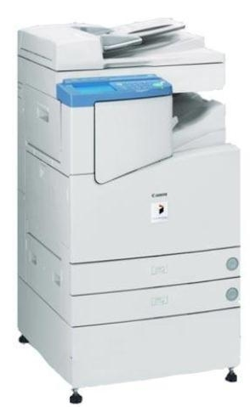

Main Unit

Type : Digital, Multifunction Imaging System
Imaging System: Laser Dry Electrostatic Transfer
Developing System :Dry Monocomponent Toner
Projection
Fixing System : RAPID Fusing System
Image Server Memory :Standard 128MB RAM + 5.1GB
HDD (Max. Capacity :Approx.4,000 Originals)
First-copy Time :5.8 Seconds from Platen Glass
6.6 Seconds from ADF
Warm-up Time :10 Seconds or Less From Sleep Mode
29 Seconds from Main Power Off
Copy/Print Speed :33 ppm (Letter)
Max. Mail Boxes Supported :100
Max. Copy Reservation :5 Jobs
Actual Resolution :600 dpi x 600 dpi
Interpolated Resolution :200 dpi x 600 dpi (Copy)
2400 dpi x 600 dpi (Print)
Halftone :256 Gradations of Gray
Duplexing :Standard Automatic Trayless Duplexing

Magnification Reduction
Enlargement :25% to 800% (in 1% increments)
Paper Supply
Standard :Dual 500-sheet Paper Cassettes
(1,000 Sheets)
Stack Bypass : (50 Sheets)
Optional :Dual 500-sheet Paper Cassettes
(1,000 Sheets)
Exposure Control :Automatic or Manual
Multiple Copies :1 to 999
Max. Original Size :1" x 17" (Ledger)
Paper Weights :17 lb. to 20 lb. Bond (Cassette)
17 lb. to 32 lb. Bond (Stack Bypass)
Power Source :120V AC, 60Hz, 15A
Drum :OPC—Estimated Yield: 25,000
Impressions
Max. Duty Cycle :120,000 Impressions Per Month
Toner: Estimated Yield :8,000 Images per KG
Dimensions :H x W x D): 40-1/8" x 22-1/4" x 26-3/4"
(1,020mm x 565mm x 678mm)
Weight :176.3 lb. (80kg)
Scanning: Up to A3 size scan from copier
Mail box: Up to 6 GB memory can store in copier
Feeder-(ADF) Automatic Document Feeder-(ADF)

We are the canon Rc1 Dealers in Bangalore contact: canonrc1bangalore@gmail.com 9060002096 .9945457636.9880988731

